FIRST ANNOUNCEMENT
Dear Madam / Sir,
It is our honor and pleasure to invite you to the Second Macedonian Road Congress 2022, which will be held on November 3 - 4, 2022 in Skopje, in the hotel "Double
Tree by HILTON".
The occasion for the organization of this top scientific and professional event – Second Macedonian Road Congress 2022 is the 55th anniversary since the founding of the Macedonian Association of Road Engineers, as the ending event in the celebration of this great jubilee on one of the oldest professional associations in the Republic of Macedonia.
We are expecting this Second Macedonian Road Congress 2022, to be a successful continuity of the First Macedonian Road Congress in 2019 which had more than 350 participants from 16 countries in Europe, with more than 60 scientific papers.
The Second Macedonian Road Congress is organized at the initiative of the Macedonian Association of Road Engineers (MARE), and in cooperation with the „St’s Cyril and Methodius“ University in Skopje (UKIM), Civil Engineering Faculty in Skopje (GF), the Chamber of certified architects and certified engineers of the Republic of Macedonia (KOAOI), Engineering Institution of Republic of Macedonia (IMI), Republic Council on Road Traffic Safety, and Public Enterprise for maintenance of national and regional roads „Makedonijapat“ - Skopje.
In addition to the congress is the large investment cycle in the road infrastructure that
takes place in the Republic of Macedonia in the amount of over 1 billion euros,
expressed through the construction of 2 motorways, several express roads and more
regional roads. Four more sections of motorways are also expected to start with construction soon.
Scientists, professors and experts in the field of roads, from Macedonia and Europe have announced their participation which is an opportunity to exchange positive experiences and knowledge.

Topics of Second Macedonian Road Congress:
- Planning and designing
- Management, construction and maintenance
- Road traffic safety
- Environmental protection and sustainable development
- Infrastructure facilities
- Transport policy and financing
- ITS and new technologies in traffic
- Free and related topics in the field of roads and presentation of new projects
On this occasion, we invite all domestic and foreign experts to present their own research and experiences in the field of roads on the anticipated topics.
For all Congress participants a fee is planned, with a discount for early registration. For students of doctoral studies and postgraduate students of the Civil Engineering Faculties an additional discount follows.
The official languages of the Congress are Macedonian and English.
Also, we call on all domestic and foreign companies to help the organization of this great international gathering, through the promotion and advertising of their companies by choosing one of the sponsorship packages.

For participants without paper deadline for registration is: 30. 10. 2022

Fees for participation in the Congress:
- For foreign participants
Until 15. 7. 2022 | 190 €
Until 15. 9. 2022 | 210 €
Until 15. 9. 2022 | 230 €

With one paid registration fee, it is possible to publish only 2 papers by the same author.
The registration fee includes:
- Attendance at Congress and all lectures
- A copy of the printed Book of Abstracts
- A copy of proceedings to USB
- All additional congressional and promotional materials
- Cocktail for welcome
- Refreshments during breaks provided by the Program of the Congress
- Lunches provided by the Program of the Congress
- Gala dinner
- A copy of the scientific and professional journal „Roads“
- Certificate for participation at the congress by the „KOAOI“ valued by CPD points

Note: The hotel accommodation is not included in the registration fee!
All additional information regarding the Congress can be found on the website:
www.congress.mare.org.mk
where you can apply for participation and submission of
abstracts.

Contact:
Macedonian Association of Road Engineers „Via Vita“
(Civil Engineering Faculty)
P. Box 560
„Partizanski odredi“ Blvd. No. 24
1000 Skopje
Republic of Macedonia
e-mail: congress@mare.org.mk

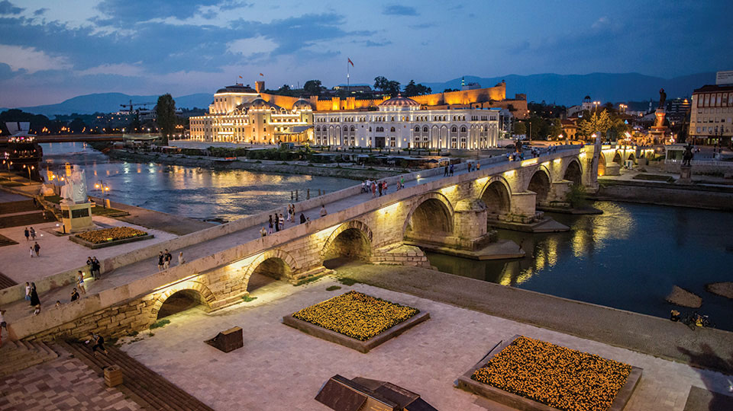
The Stone Bridge is a bridge across the Vardar River in Skopje, the capital of the Republic of Macedonia. The bridge is considered a symbol of Skopje and is the main element of the coat of arms of the city, which in turn is incorporated in the city’s flag.

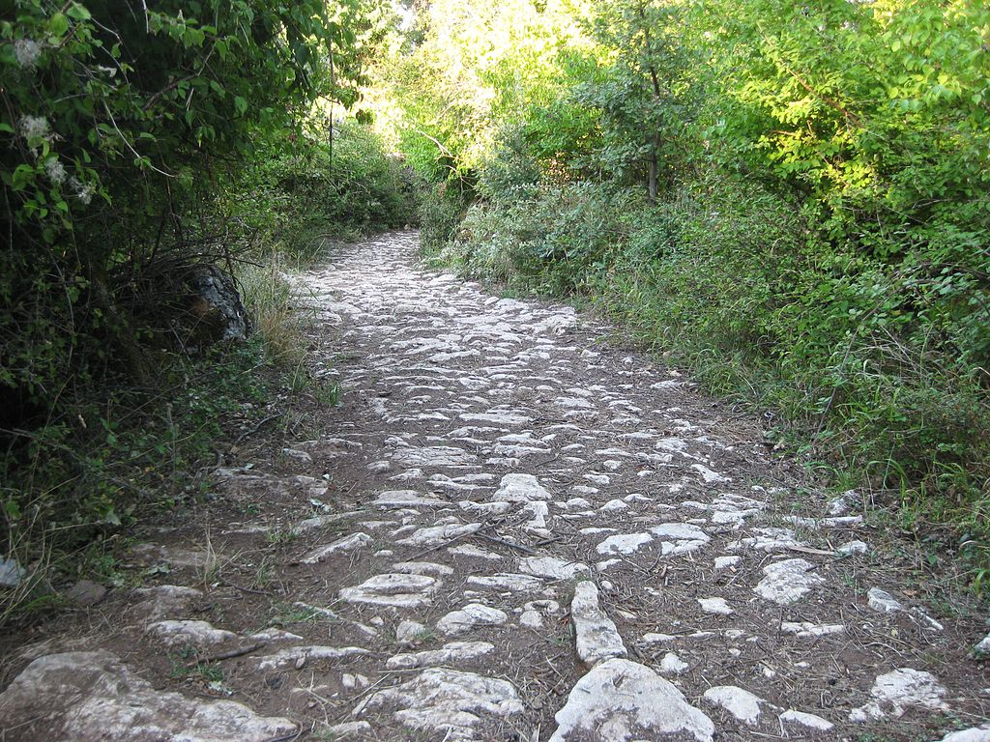
The Via Egnatia was a road constructed by the Romans in the 2nd century before Christ. It crossed Illyricum, Macedonia and Thracia, running through territory that is now part of modern Albania, Macedonia, Greece, and European Turkey as a continuation of the Via Appia.

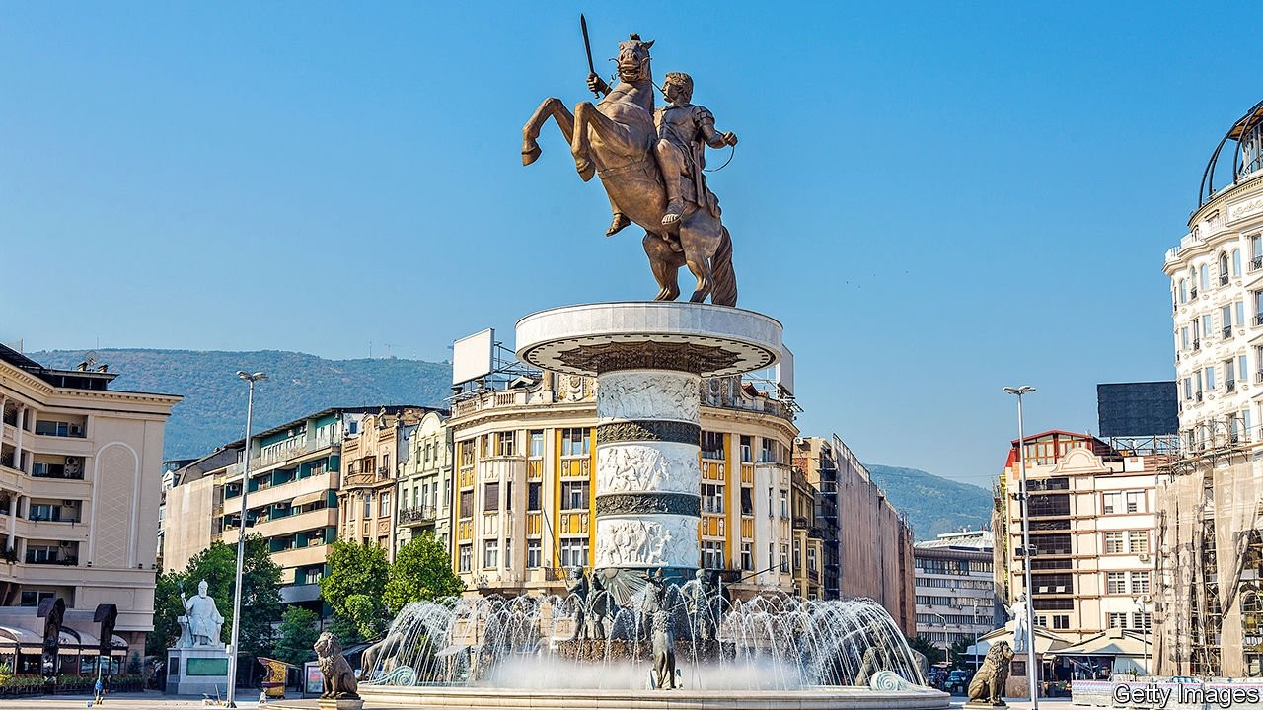
Alexander III of Macedon, commonly known as Alexander the Great, was a king of the ancient kingdom of Macedonia. By the age of thirty, he had created one of the largest empires in history, stretching from Greece to northwestern India. He was undefeated in battle and is widely considered to be one of history’s greatest and most successful military commanders.

